09/29/2017

Install MySQL. Appears to use x86 version. Files are in setups/mysql.

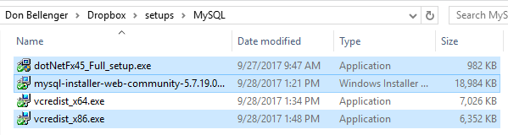

On windows 10, prerequisites are dot net 4.5, and c Redistributable 2013. Then run mysql_installer_web… as administrator multiple times to install the server, and the workbench, and the obdc drivers.

Install Navicat for MySql from the web. My license key seems to have expired.

Windows Powershell is already installed.

Install ConEmu Stable from web. Start it, and set to run over Powershell as Administrator. Instructions are at <https://conemu.github.io/en/ConEmuFAQ.html> . Right click the “Settings” at the right top, and click of colors, and pick Solarized Light scheme.

Download TortoiseGit from the web. It will tell you to install Git for Windows 2.0, first, and provide a link. Here is my copy of git and Tortoise Git installed on 10/4/2017.

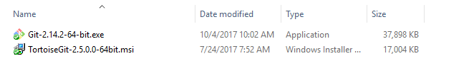

Install sublime text 3 from the web. (<https://www.sublimetext.com/download>)

Install Araxis Merge from setup file in setups.

Create projects/cbsites/bbsgdv1

Clone code from github. Belldrfree. <https://github.com/>. Go to uisdesign1-dev1.

Install commandbox with Java included (assuming Java is not already there) from the web. Instructions are at <https://commandbox.ortusbooks.com/content/getting_started_guide.html>. Download link is